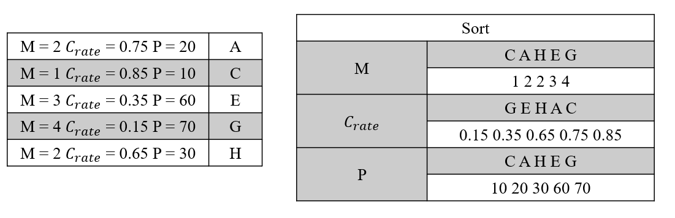

Figure 11. An example of crowding distance